**FTW**

**Architecture/Design Document**

**Table of Contents**

1. **INTRODUCTION**
2. **SYSTEM BEHAVIOR**
3. **DESIGN PATTERN**

**3.1 Model View Controller**

**3.2 Detailed Class Design**

1. **TESTING**
2. **INSTALL AND RUN**

**1 Introduction**

This document describes the architecture and design for the Calendar application which will allow users of all ages who want to use calendar app to view events or to keep track on daily/weekly/monthly events. Calendar application will allow users to add, update, delete, check time and color code events. Our application will send notification to remind users of their upcoming events.

The purpose of this document is to describe the architecture and design for UTD students.

Users - create events, start/end time, notify, view, color, remove events.

Developers - they want calendar application that will notify users of event

**2 System Behavior**

Here is the use case view of the calendar application and design. 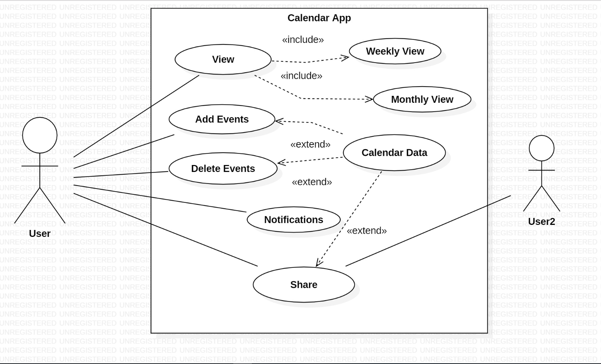

**3 Design Pattern**

**3.1 Model View Controller**

Model: DataBaseHelper and Event Classes

View: Activity XML Layouts

Controller: Activity Classes

**3.2 Details Class Design**

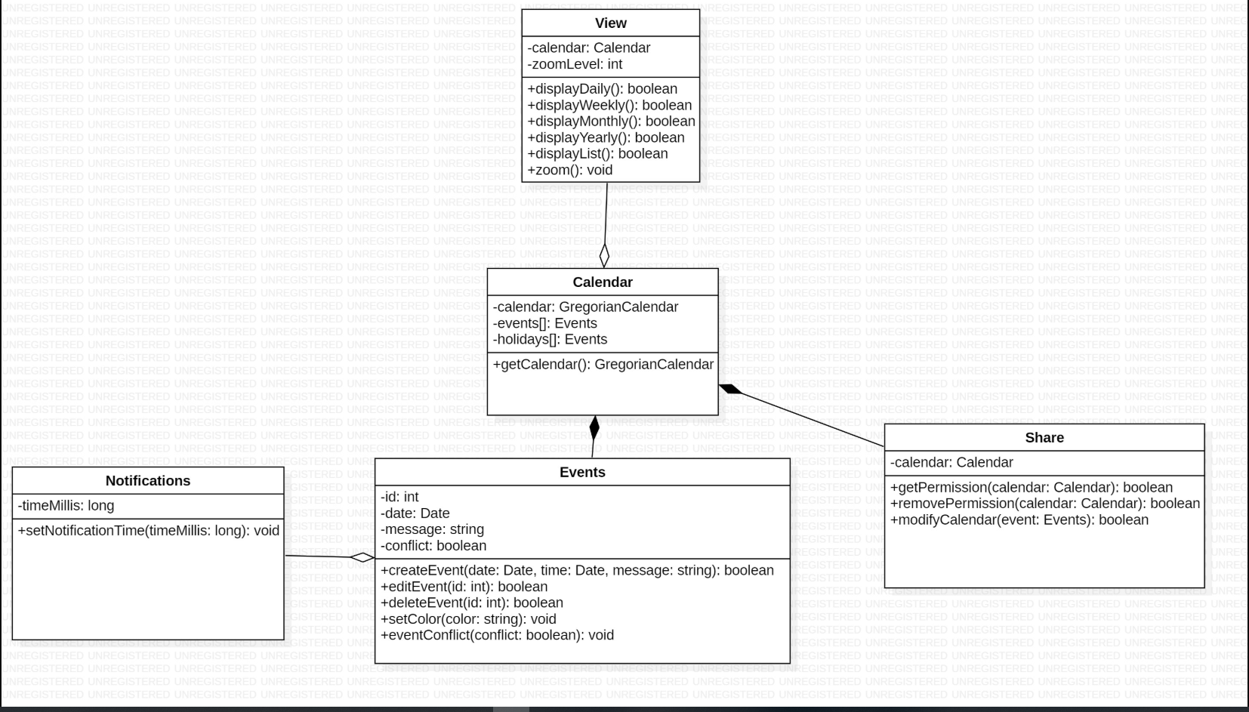

**4 Testing**

Gabriel – Test class DatabaseHelperJUnit

Location:

cs3354-FTW/Calendar_App/app/src/androidTest/java/com/ftw/calendar_app/DatabaseHelperJUnit.java

Kyle – Test class EventJUnit

Location:

cs3354-FTW/Calendar_App/app/src/androidTest/java/com/ftw/calendar_app/EventJUnit.java

Emanuel – Test class EventJUnitEmanuel

Location:

cs3354-FTW/Calendar_App/app/src/test/java/com/ftw/calendar_app/EventJUnitEmanuel.java

Steven – Test class EventJUnitSteven

Location:

cs3354-FTW/Calendar_App/app/src/test/java/com/ftw/calendar_app/EventJUnitSteven.java

5 **Install and Run**

To clone and build our project follow these directions.

1. Run, in the desired directory:
   1. git clone <https://github.com/EprimePRO/cs3354-FTW>
2. Open the following folder in Android Studio:
   1. .\ cs3354-FTW\Calendar_App
3. Click the run button or press (Shift+F10) and select an android device
4. Wait for the app to build and install on the device.